Day-4

Task:01

Js code package com.selenium.nithish.demo; import org.openqa.selenium.By; import org.openqa.selenium.WebDriver; import org.openqa.selenium.WebElement; import org.openqa.selenium.chrome.ChromeDriver; import org.openqa.selenium.chrome.ChromeOptions; import io.github.bonigarcia.wdm.WebDriverManager; public class D4T1 { public static void main(String[] args) {

WebDriverManager.chromedriver().setup(); ChromeOptions co=new ChromeOptions(); co.addArguments("--remote-allow-origins=*");

WebDriver driver=new ChromeDriver(co);

driver.get("https://demo.opencart.com/index.php?route=account/register&language=e n-gb");

driver.manage().window().maximize();

WebElement fn=

driver.findElement(By.id("input-firstname"));

fn.sendKeys("Arun");

WebElement ln= driver.findElement(By.id("input-lastname")); ln.sendKeys("Kumar");

WebElement em= driver.findElement(By.id("input-email")); em.sendKeys("Kumar@gmail.com");

WebElement pwd=

driver.findElement(By.id("input-password"));

pwd.sendKeys("Kumar@1");

}

}

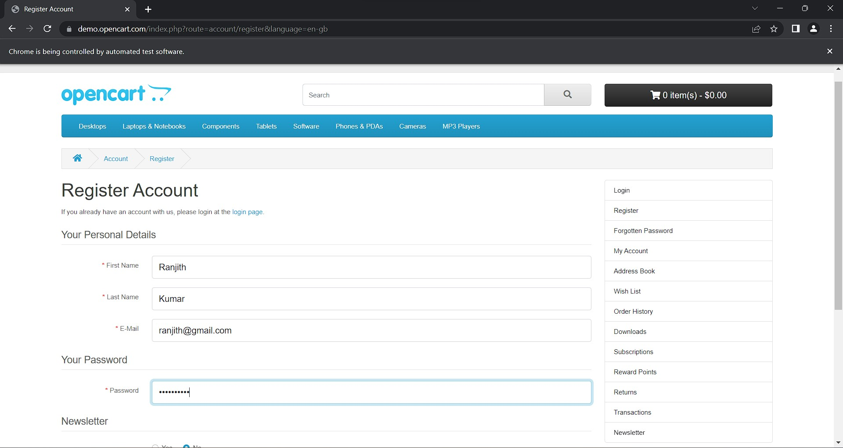

Task:02

Js code package com.selenium.nithish.demo; import org.openqa.selenium.By; import org.openqa.selenium.JavascriptExecutor; import org.openqa.selenium.WebDriver; import org.openqa.selenium.WebElement; import org.openqa.selenium.chrome.ChromeDriver; import org.openqa.selenium.chrome.ChromeOptions; import io.github.bonigarcia.wdm.WebDriverManager; public class D4T2 {

public static void main(String[] args) throws Exception { WebDriverManager.chromedriver().setup(); ChromeOptions co=new ChromeOptions(); co.addArguments("--remote-allow-origins=*");

WebDriver driver=new ChromeDriver(co);

driver.get("https://demo.opencart.com/index.php?route=account/register&language=e n-gb");

driver.manage().window().maximize();

Thread.sleep(3000);

JavascriptExecutor js = (JavascriptExecutor) driver; js.executeScript("window.scrollBy(0,1000)","");

WebElement fn=

driver.findElement(By.xpath("//*[@id=\"input-firstname\"]")); fn.sendKeys("nithish");

WebElement ln=

driver.findElement(By.xpath("//*[@id=\"input-lastname\"]")); ln.sendKeys("Kumar");

WebElement em=

driver.findElement(By.xpath("//*[@id=\"input-email\"]")); em.sendKeys("nithish@gmail.com");

WebElement pwd=

driver.findElement(By.xpath("//*[@id=\"input-password\"]")); pwd.sendKeys("Kumar@1188");

WebElement sub=

driver.findElement(By.xpath("//*[@id=\"input-newsletter-yes\"]")); sub.click();

}

}

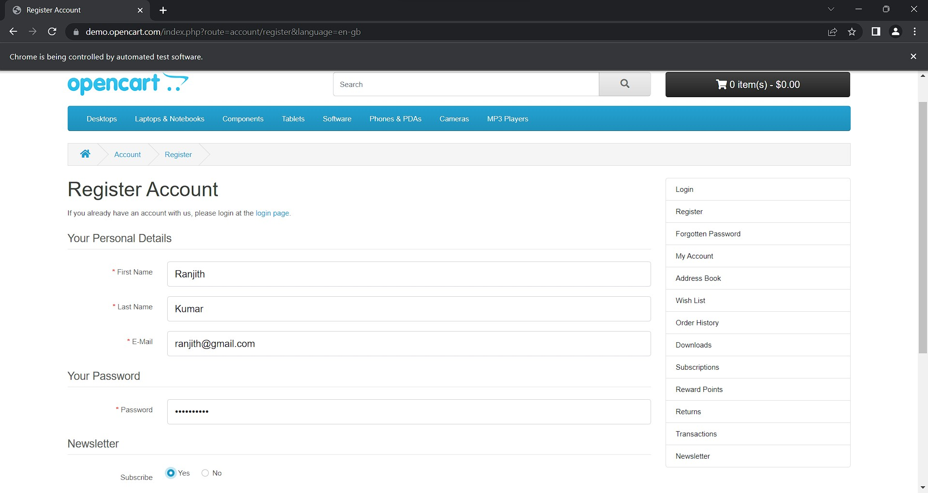

Task:03

Js code package com.selenium.nithish.demo; import org.openqa.selenium.By; import org.openqa.selenium.JavascriptExecutor; import org.openqa.selenium.WebDriver; import org.openqa.selenium.chrome.ChromeDriver; import org.openqa.selenium.chrome.ChromeOptions; import io.github.bonigarcia.wdm.WebDriverManager; public class D4T3 {

public static void main(String[] args) throws Exception {

WebDriverManager.chromedriver().setup(); ChromeOptions co=new ChromeOptions(); co.addArguments("--remote-allow-origins=*"); WebDriver driver=new ChromeDriver(co);

driver.get("https://j2store.net/free/"); driver.manage().window().maximize();

Thread.sleep(3000);

JavascriptExecutor js = (JavascriptExecutor) driver; js.executeScript("window.scrollBy(0,1000)",""); driver.findElement(By.linkText("Clothing (5)")).click(); driver.navigate().back(); Thread.sleep(3000); driver.navigate().forward(); Thread.sleep(3000); driver.navigate().refresh(); driver.quit();

}

}

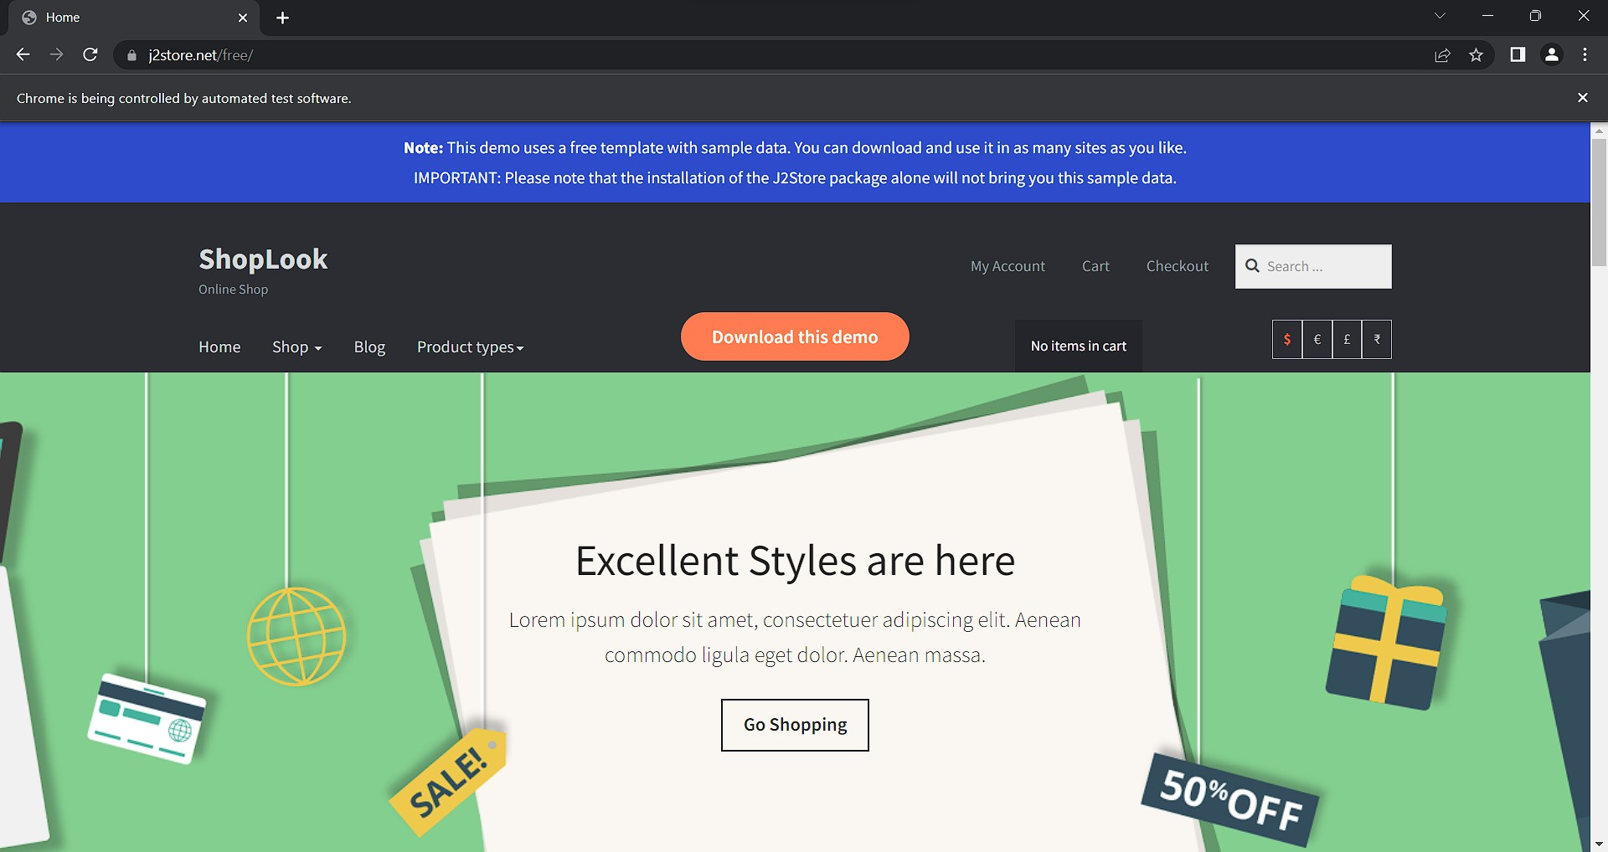

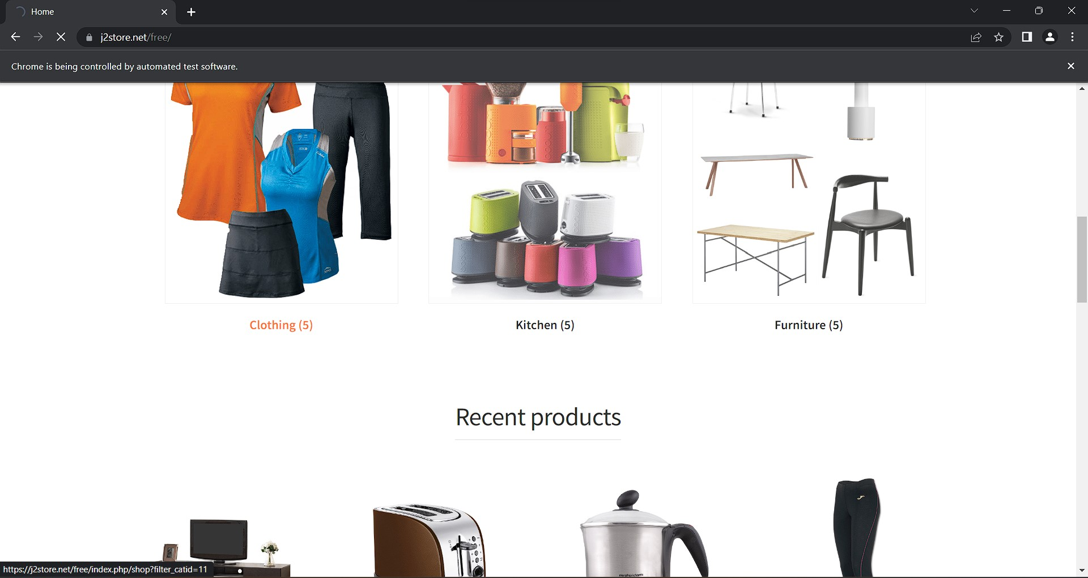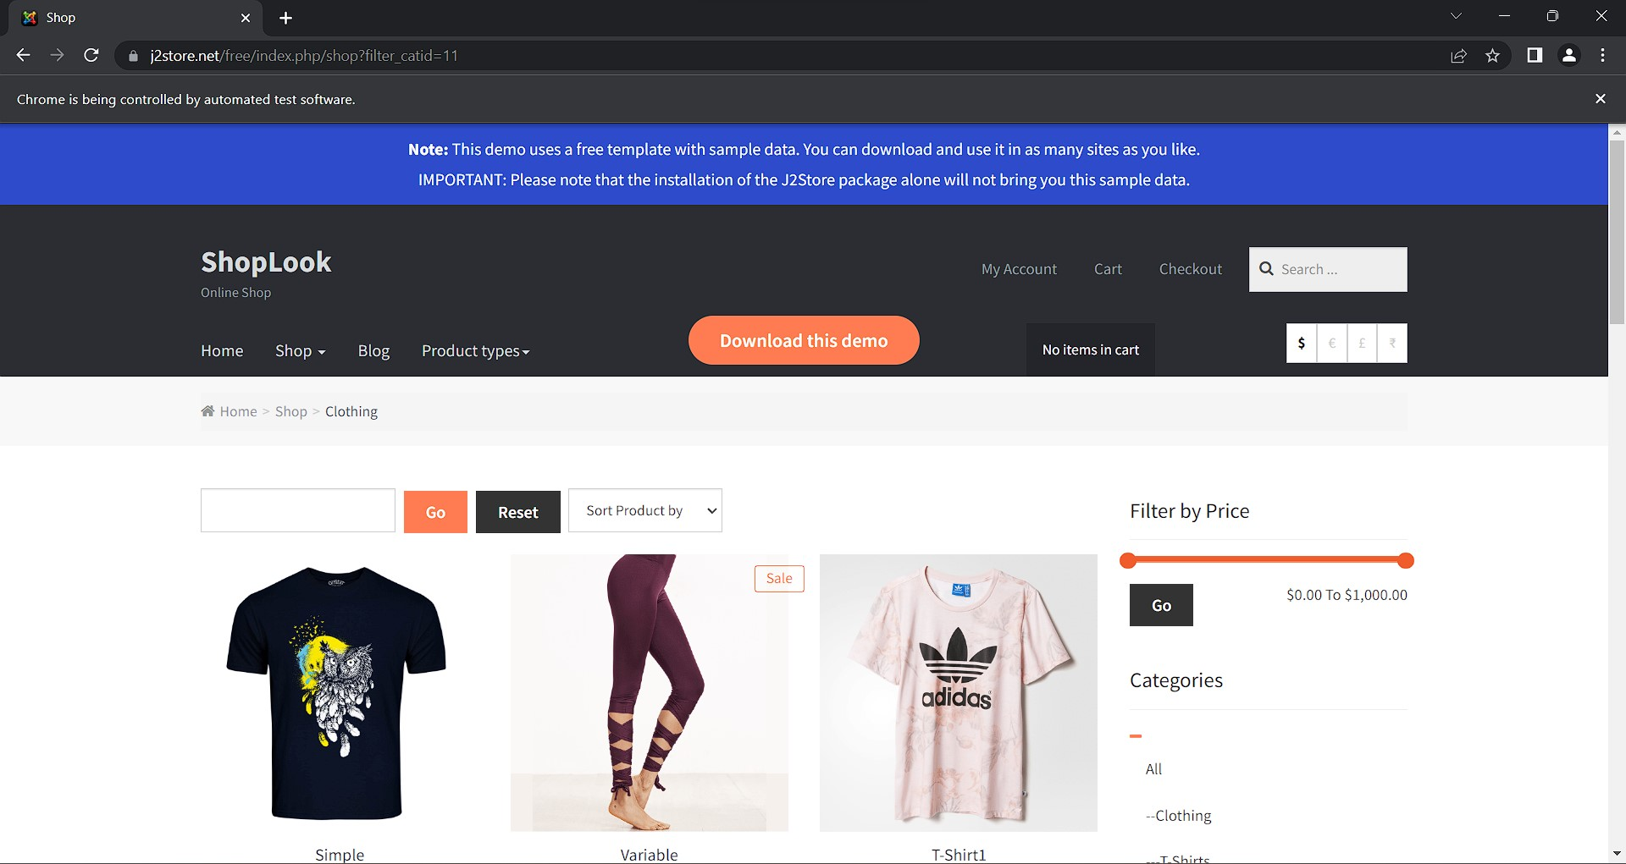

Task:04

Js code package com.selenium.nithish.demo; import org.openqa.selenium.JavascriptExecutor; import org.openqa.selenium.WebDriver; import org.openqa.selenium.chrome.ChromeDriver; import org.openqa.selenium.chrome.ChromeOptions; import io.github.bonigarcia.wdm.WebDriverManager; public class D4T4 {

public static void main(String[] args) throws Exception {

// TODO Auto-generated method stub

// Driver setup

WebDriverManager.chromedriver().setup(); ChromeOptions co=new ChromeOptions(); co.addArguments("--remote-allow-origins=*");

WebDriver driver=new ChromeDriver(co);

//open an url

driver.get("https://j2store.net/free/"); driver.manage().window().maximize();

Thread.sleep(3000);

JavascriptExecutor js = (JavascriptExecutor) driver; js.executeScript("window.scrollBy(0,1000)","");

String t1=driver.getCurrentUrl();

String t2="https://j2store.net/free/"; System.out.println(t1); if(t1.equals(t2))

{ System.out.println("Correct Url");

} else

{ System.out.println("Wrong Url");

}

}

}

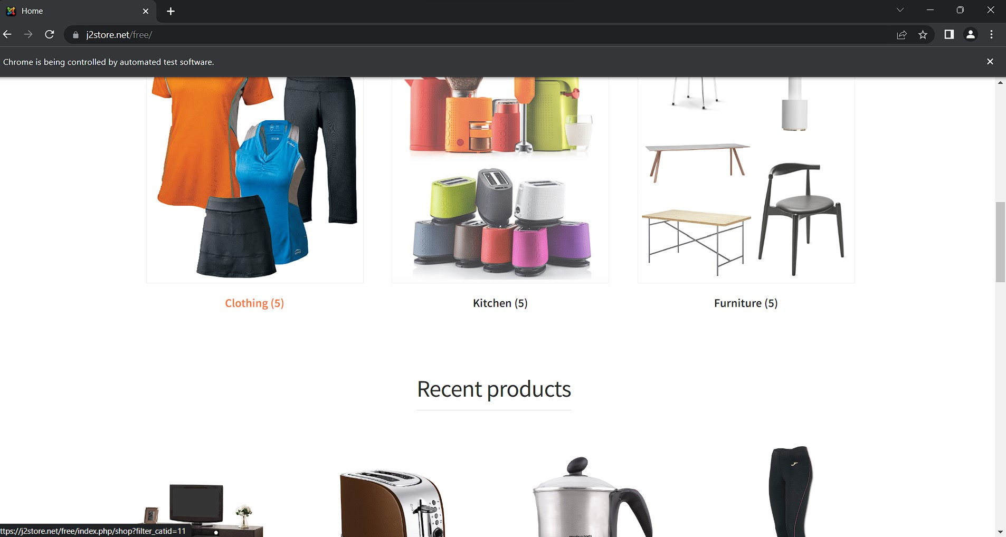

Task:05-01

Js code package com.selenium.nithish.demo; import java.util.List; import org.openqa.selenium.By; import org.openqa.selenium.JavascriptExecutor; import org.openqa.selenium.WebDriver; import org.openqa.selenium.WebElement; import org.openqa.selenium.chrome.ChromeDriver; import org.openqa.selenium.chrome.ChromeOptions; import io.github.bonigarcia.wdm.WebDriverManager; public class D4T5_1 {

public static void main(String[] args) throws Exception { WebDriverManager.chromedriver().setup(); ChromeOptions co=new ChromeOptions(); co.addArguments("--remote-allow-origins=*"); WebDriver driver=new ChromeDriver(co);

driver.get("https://j2store.net/free/"); driver.manage().window().maximize();

Thread.sleep(3000);

JavascriptExecutor js = (JavascriptExecutor) driver; js.executeScript("window.scrollBy(0,1000)",""); driver.findElement(By.linkText("Clothing (5)")).click();

List<WebElement> l1=driver.findElements(By.xpath("//h2[@class='product-title']"));

for(WebElement link:l1)

{

System.out.println(link.getText());

}

}

}

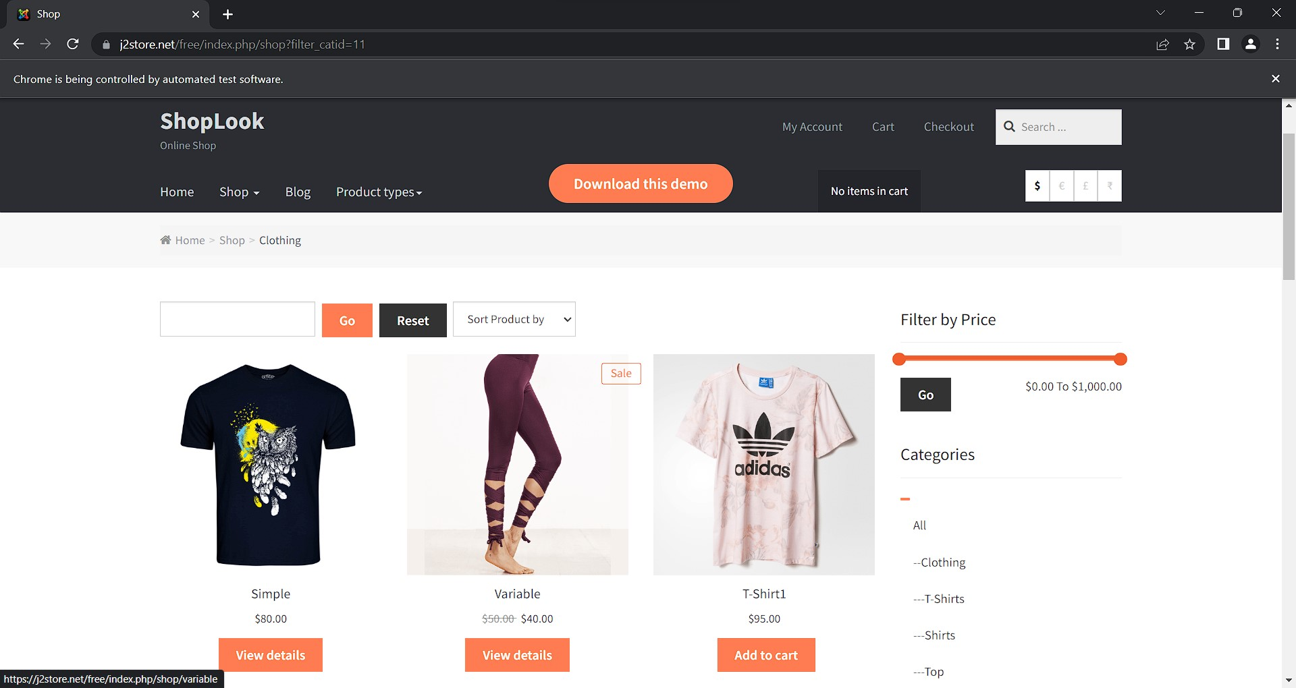

Task:05-02

Js code package com.selenium.nithish.demo; import java.util.List; import org.openqa.selenium.By; import org.openqa.selenium.JavascriptExecutor; import org.openqa.selenium.WebDriver; import org.openqa.selenium.WebElement; import org.openqa.selenium.chrome.ChromeDriver; import org.openqa.selenium.chrome.ChromeOptions; import io.github.bonigarcia.wdm.WebDriverManager; public class D4T5_1 {

public static void main(String[] args) throws Exception { WebDriverManager.chromedriver().setup(); ChromeOptions co=new ChromeOptions(); co.addArguments("--remote-allow-origins=*"); WebDriver driver=new ChromeDriver(co);

driver.get("https://j2store.net/free/"); driver.manage().window().maximize();

Thread.sleep(3000);

JavascriptExecutor js = (JavascriptExecutor) driver; js.executeScript("window.scrollBy(0,1000)",""); driver.findElement(By.linkText("Clothing (5)")).click();

List<WebElement> l1=driver.findElements(By.xpath("//h2[@class='product-title']"));

for(WebElement link:l1)

{

System.out.println(link.getText());

}

}

}

